**Comparative Analysis Report: Web Scraping Tools**

**Introduction**

This report presents a comparative analysis of three web scraping tools: BeautifulSoup, Scrapy, and Selenium. The analysis focuses on their performance in scraping a single webpage, evaluating factors such as speed, ease of use, and suitability for different types of web content.

**Methodology**

The tools were evaluated based on the time taken to scrape a single webpage. Each tool's performance was measured under similar conditions to ensure a fair comparison.

**Comparison Overview**

|  |  |  |
| --- | --- | --- |
| **Tool** | **Description** | **Time Taken (seconds)** |
| **BeautifulSoup** | A Python library for parsing HTML and XML, ideal for simple static content. | 5 |
| **Scrapy** | An open-source framework for large-scale scraping, optimized for structured data. | 2 |
| **Selenium** | A web automation tool that can handle dynamic content by simulating user interactions. | 15 |

**Performance Visualization**

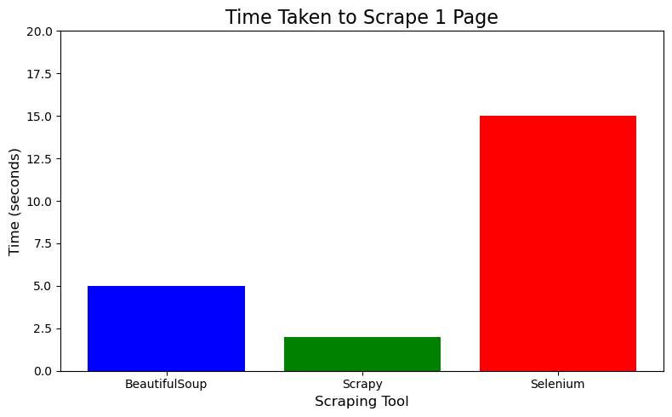

**Analysis of Results**

1. **Speed**:
   * **Scrapy** was the fastest tool, taking only **2 seconds** to scrape a single page, making it suitable for larger datasets and higher-volume scraping tasks.
   * **BeautifulSoup** performed moderately, with a time of **5 seconds**, effective for smaller projects that require straightforward data extraction from static HTML.
   * **Selenium** was the slowest, at **15 seconds**, primarily due to the overhead of browser automation and rendering of dynamic content.
2. **Ease of Use**:
   * **BeautifulSoup** is the simplest tool to set up and use, especially for beginners, making it ideal for quick tasks involving static pages.
   * **Scrapy** requires a moderate understanding of its framework and structure but offers great efficiency for larger projects.
   * **Selenium** involves a steep learning curve, as it requires knowledge of browser interactions and may require additional handling for various elements.
3. **Handling Dynamic Content**:
   * **BeautifulSoup** cannot handle dynamic JavaScript-rendered content effectively, limiting its use cases.
   * **Scrapy** has some capabilities for handling dynamic content, but it requires additional configurations.
   * **Selenium** excels at handling dynamic web content, making it suitable for interactive websites but at the cost of speed.

**Conclusion**

In conclusion, the choice of web scraping tool depends on the specific requirements of the task:

* BeautifulSoup is best for quick, simple scraping tasks involving static HTML pages.
* Scrapy is the ideal choice for large-scale scraping, providing speed and efficiency.
* Selenium is necessary for scraping dynamic, JavaScript-heavy websites, although it may be slower and more complex to use.